Nama : Pradana Argo Pangestu

Nim : 2311104079

JURNAL 5

1. 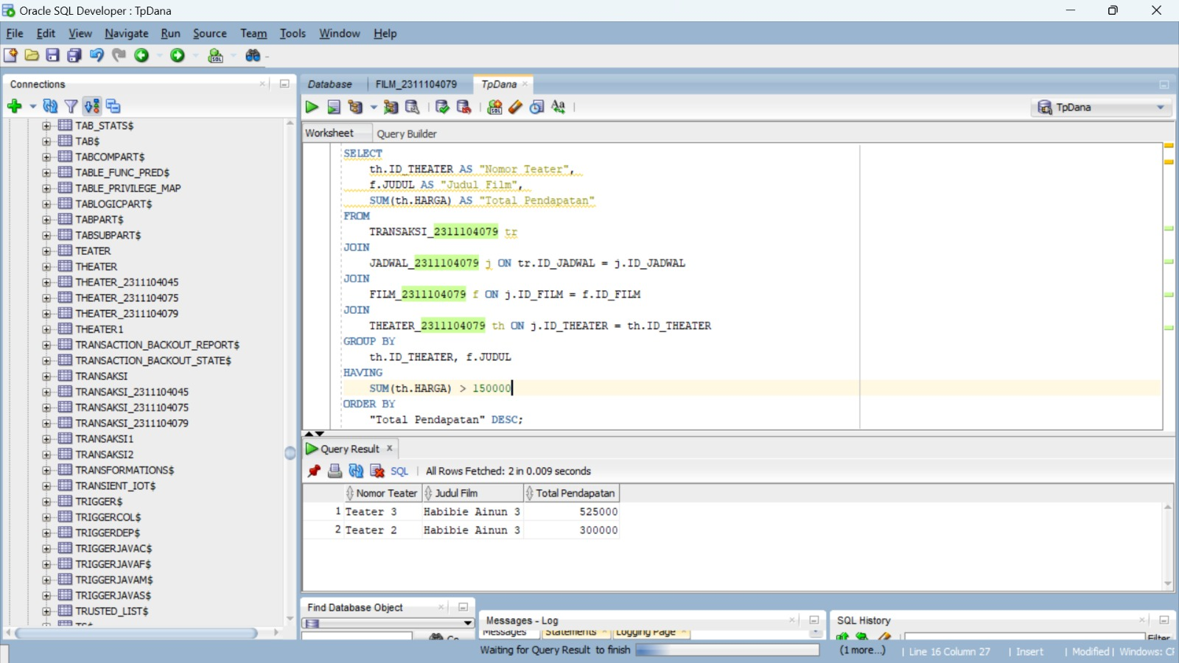

SELECT

th.ID_THEATER AS "Nomor Teater",

f.JUDUL AS "Judul Film",

SUM(th.HARGA) AS "Total Pendapatan"

FROM

TRANSAKSI_2311104079 tr

JOIN

JADWAL_2311104079 j ON tr.ID_JADWAL = j.ID_JADWAL

JOIN

FILM_2311104079 f ON j.ID_FILM = f.ID_FILM

JOIN

THEATER_2311104079 th ON j.ID_THEATER = th.ID_THEATER

GROUP BY

th.ID_THEATER, f.JUDUL

HAVING

SUM(th.HARGA) > 150000

ORDER BY

"Total Pendapatan" DESC;

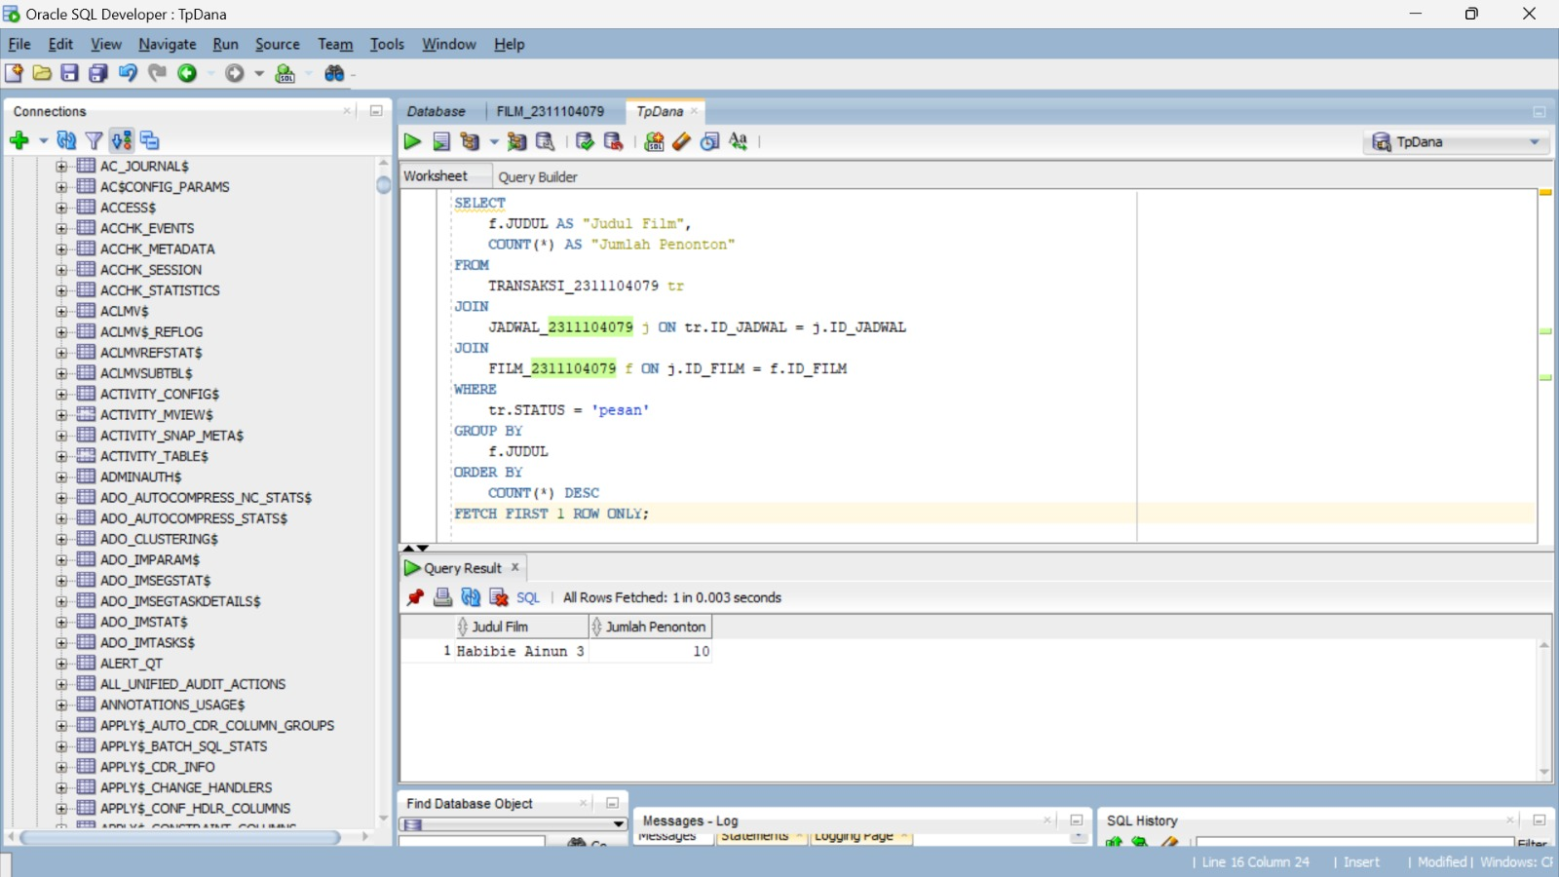

SELECT

f.JUDUL AS "Judul Film",

COUNT(*) AS "Jumlah Penonton"

FROM

TRANSAKSI_2311104079 tr

JOIN

JADWAL_2311104079 j ON tr.ID_JADWAL = j.ID_JADWAL

JOIN

FILM_2311104079 f ON j.ID_FILM = f.ID_FILM

WHERE

tr.STATUS = 'pesan'

GROUP BY

f.JUDUL

ORDER BY

COUNT(*) DESC

FETCH FIRST 1 ROW ONLY;

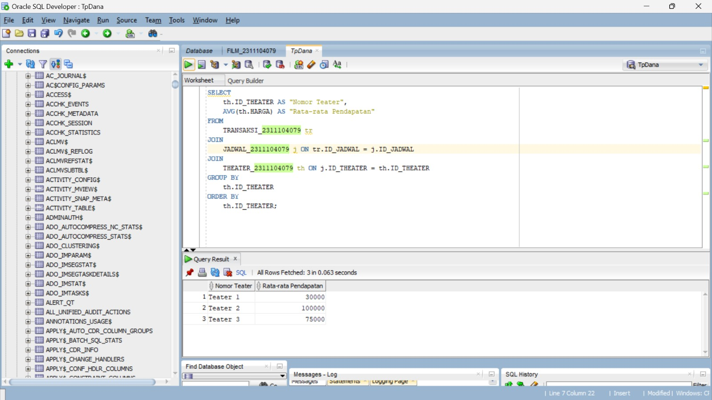

SELECT

th.ID_THEATER AS "Nomor Teater",

AVG(th.HARGA) AS "Rata-rata Pendapatan"

FROM

TRANSAKSI_2311104079 tr

JOIN

JADWAL_2311104079 j ON tr.ID_JADWAL = j.ID_JADWAL

JOIN

THEATER_2311104079 th ON j.ID_THEATER = th.ID_THEATER

GROUP BY

th.ID_THEATER

ORDER BY

th.ID_THEATER;

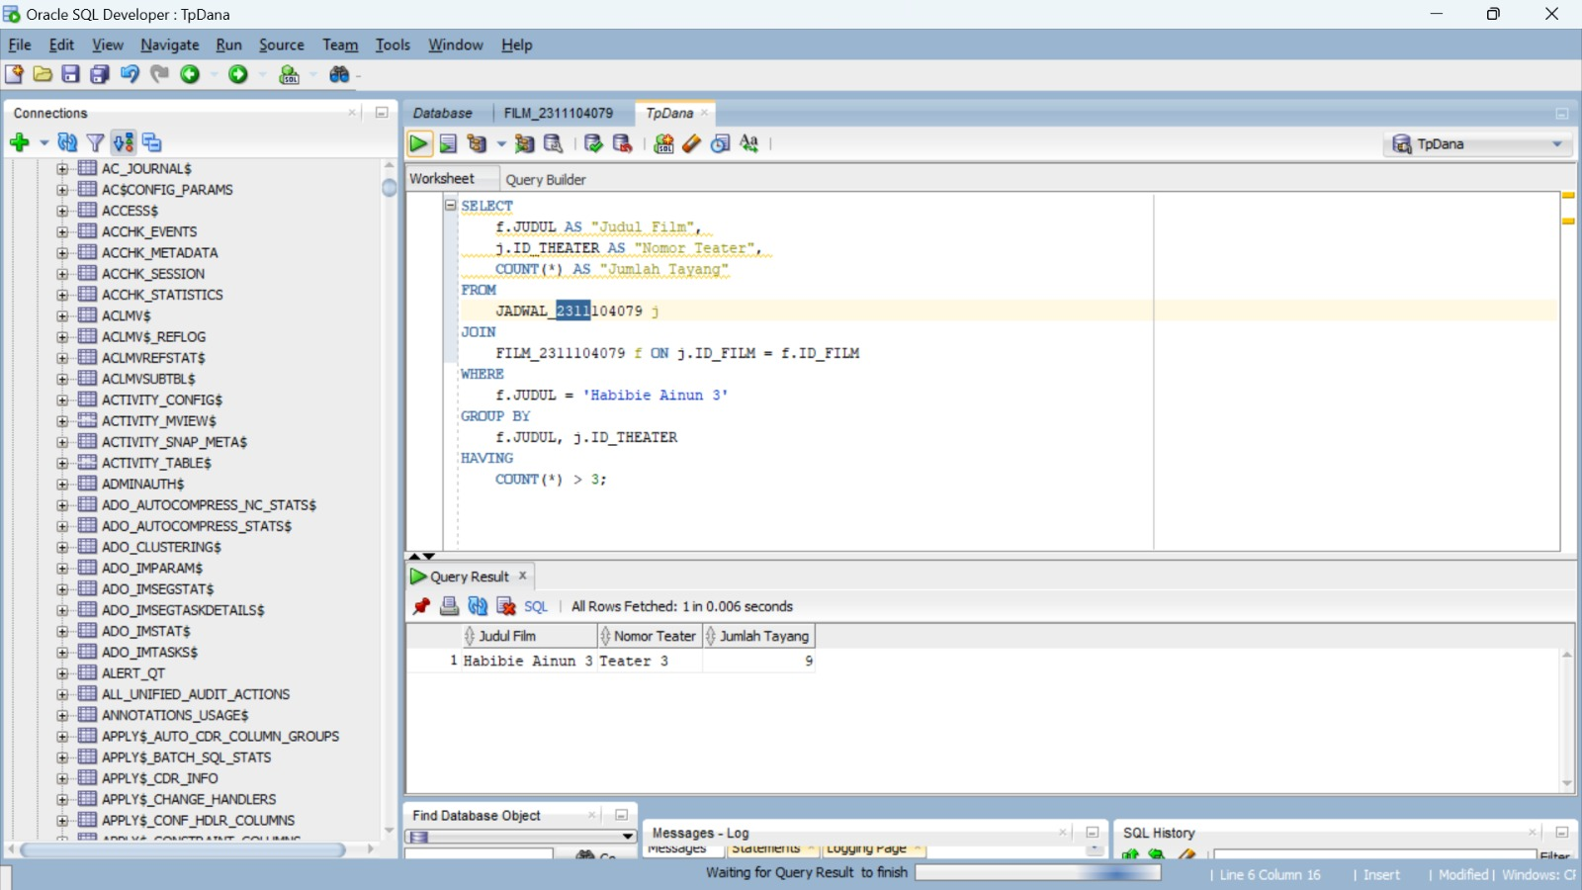

SELECT

f.JUDUL AS "Judul Film",

j.ID_THEATER AS "Nomor Teater",

COUNT(*) AS "Jumlah Tayang"

FROM

JADWAL_2311104079 j

JOIN

FILM_2311104079 f ON j.ID_FILM = f.ID_FILM

WHERE

f.JUDUL = 'Habibie Ainun 3'

GROUP BY

f.JUDUL, j.ID_THEATER

HAVING

COUNT(*) > 3;

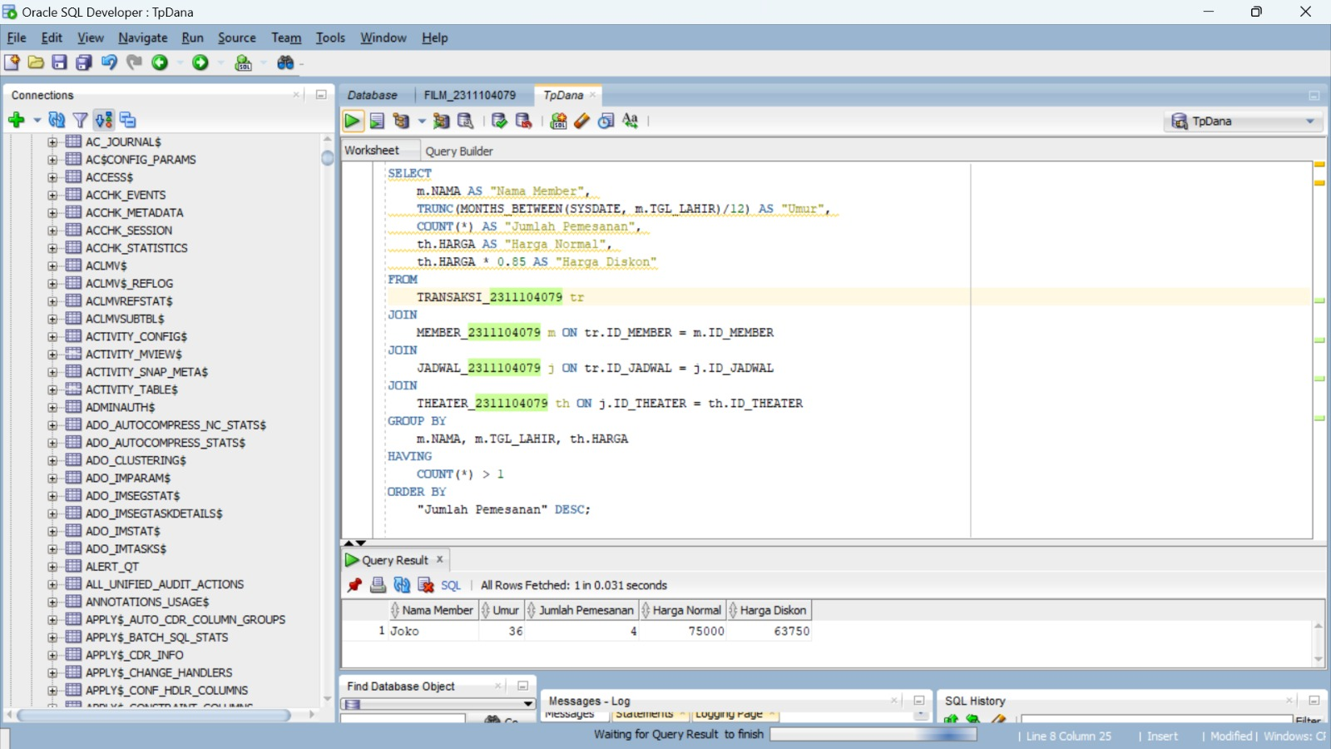

SELECT

m.NAMA AS "Nama Member",

TRUNC(MONTHS_BETWEEN(SYSDATE, m.TGL_LAHIR)/12) AS "Umur",

COUNT(*) AS "Jumlah Pemesanan",

th.HARGA AS "Harga Normal",

th.HARGA * 0.85 AS "Harga Diskon"

FROM

TRANSAKSI_2311104045 tr

JOIN

MEMBER_2311104045 m ON tr.ID_MEMBER = m.ID_MEMBER

JOIN

JADWAL_2311104045 j ON tr.ID_JADWAL = j.ID_JADWAL

JOIN

THEATER_2311104045 th ON j.ID_THEATER = th.ID_THEATER

GROUP BY

m.NAMA, m.TGL_LAHIR, th.HARGA

HAVING

COUNT(*) > 1

ORDER BY

"Jumlah Pemesanan" DESC;